**Project Design Phase**

|  |  |
| --- | --- |
| **Date** | **22 June 2025** |
| **Team ID** | **LTVIP2025TMID24654** |
| **Project Name** | **Shopez : one-stop shop for online purchases** |
| **Mentor Name** | **Dr Shaik Salma Begam** |
| **Maximum Marks** | **2 Marks** |

**Problem – Solution Fit**

**Problem–Solution Fit for Shopez**

**Problem**

Small businesses and independent sellers often face significant barriers when trying to launch an online store. Building a robust e-commerce platform from scratch is expensive, time-consuming, and requires technical expertise. Off-the-shelf solutions can be restrictive, costly, or lack the flexibility needed for unique business requirements. As a result, many sellers are unable to reach online customers or manage their sales efficiently.

**Solution**

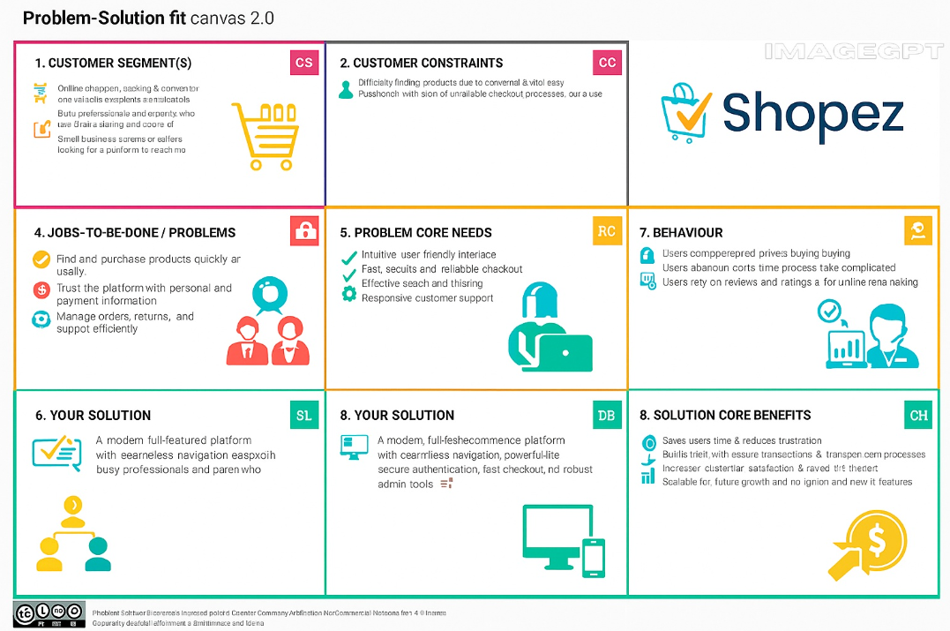This project delivers a modern, open-source e-commerce platform designed to empower small businesses and individual entrepreneurs to sell online with ease and confidence**.**